FOR IMMEDIATE RELEASE
February 11, 2019
Contact: Danielle Endvick, 715-471-0398 or dendvick@wisconsinfarmersunion.com
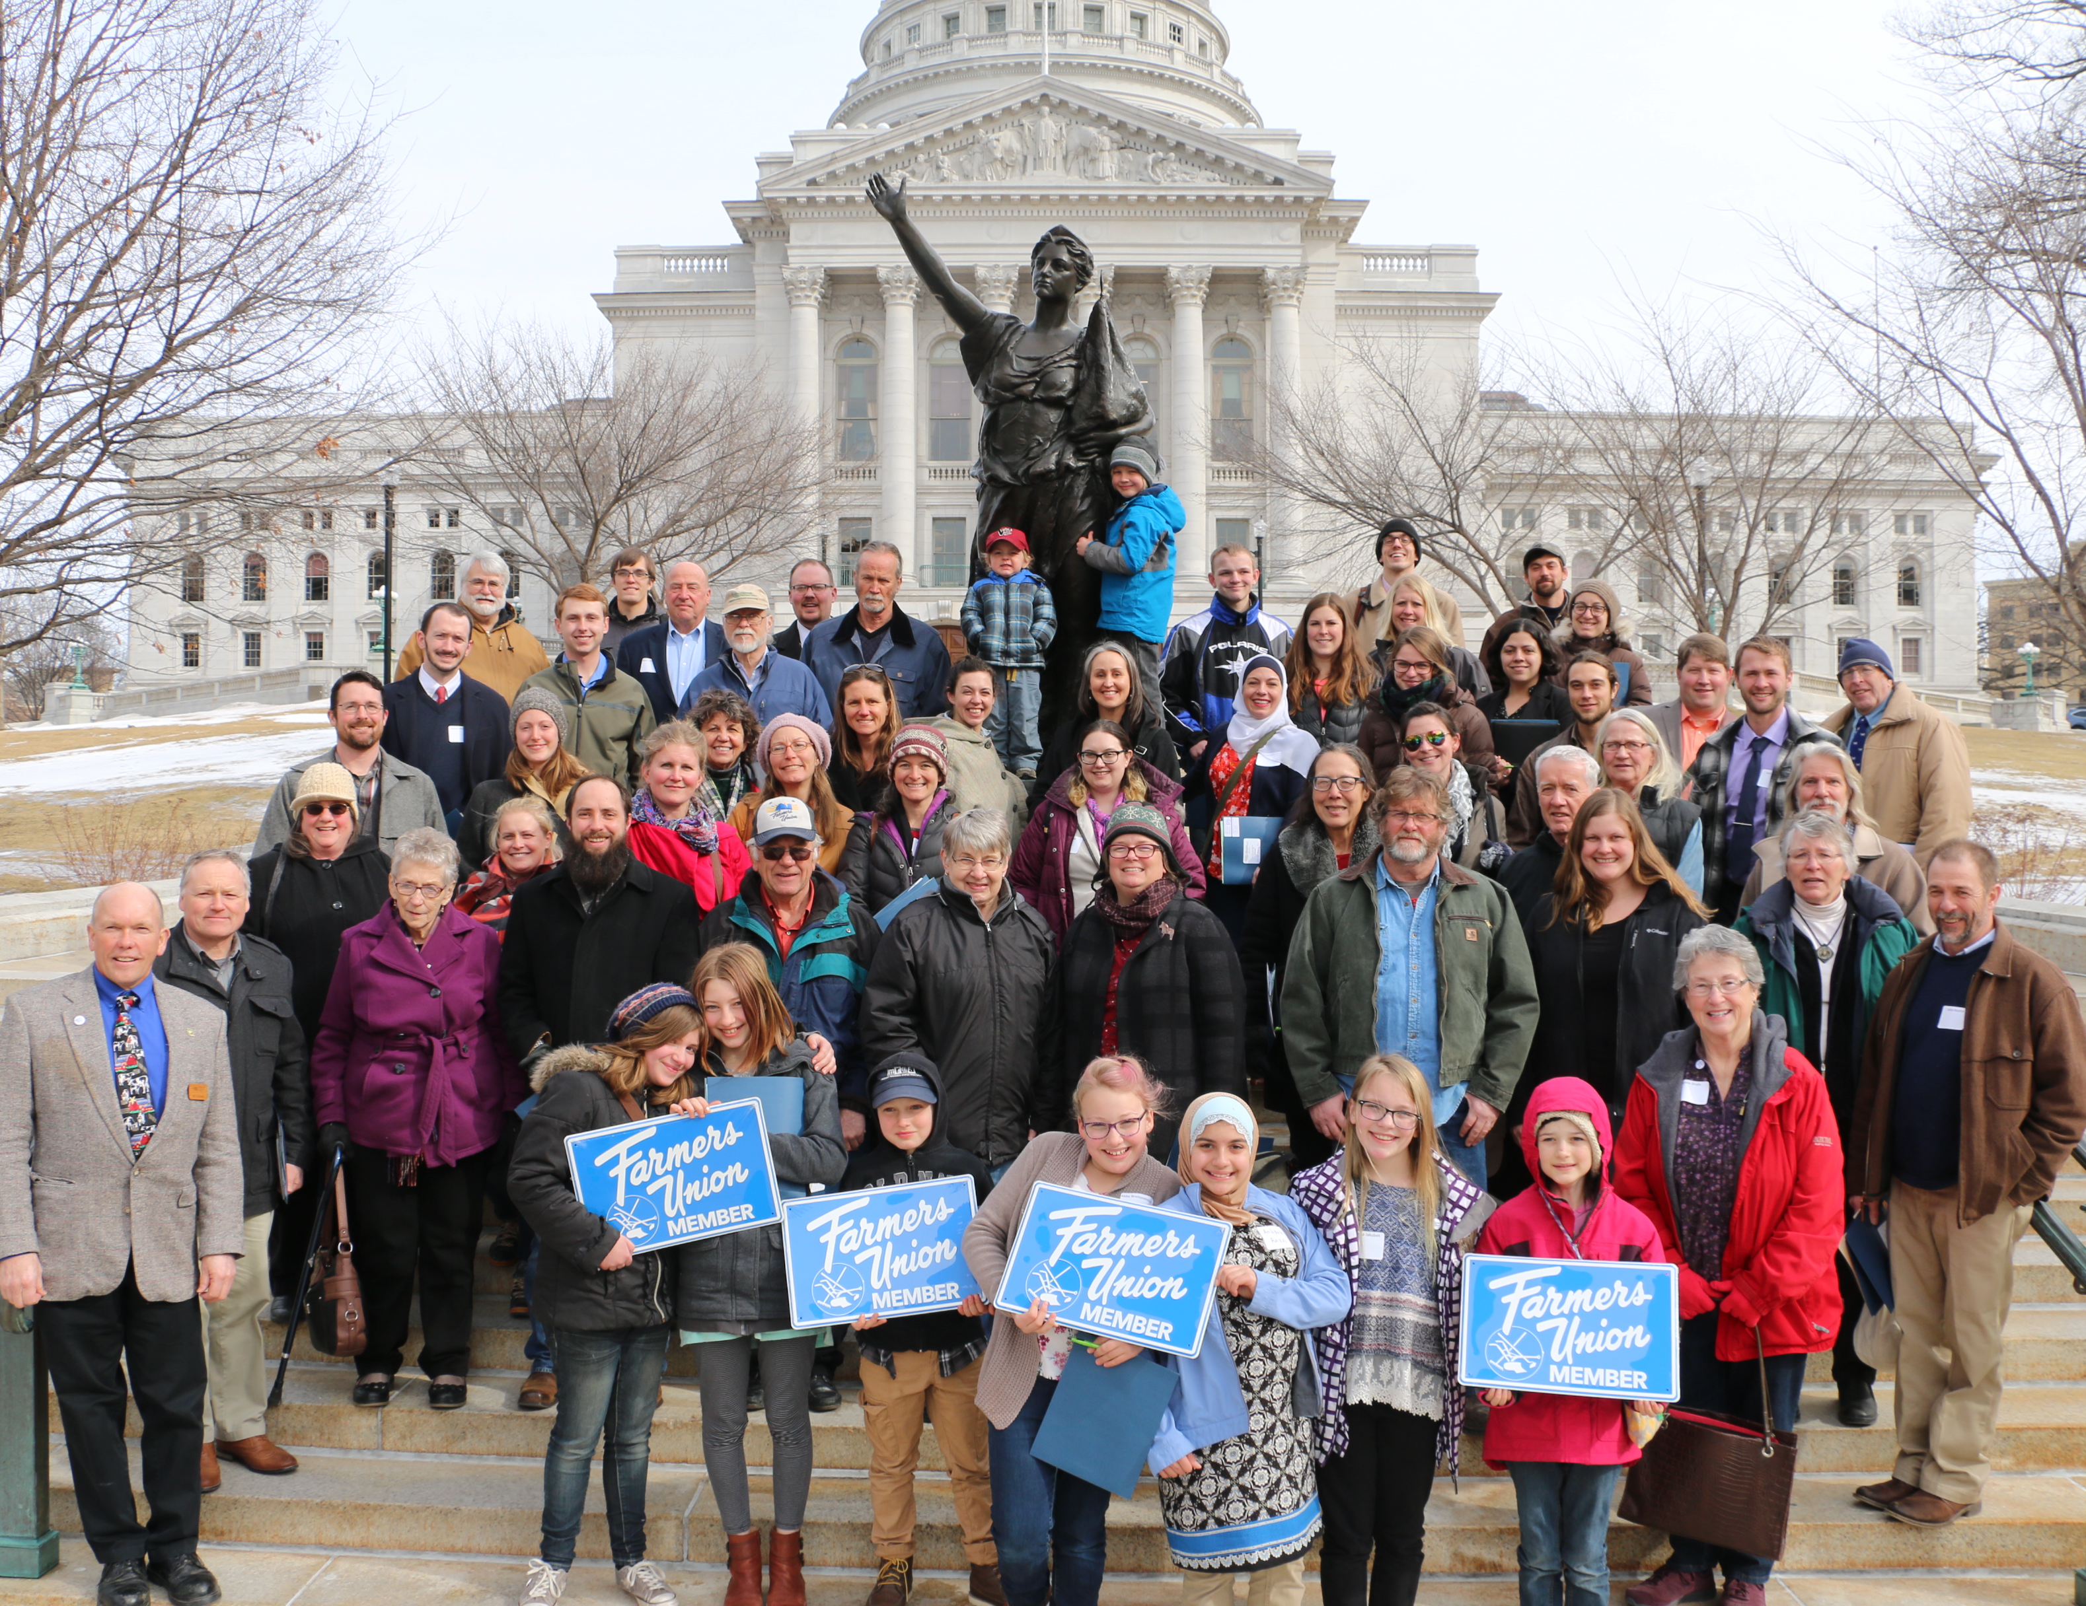
Farmers Union to host Farm and Rural Lobby Day
MADISON – Registration is open for Farm and Rural Lobby Day on Wednesday, Feb. 27 in Madison. The annual event is organized by Wisconsin Farmers Union.

WFU President Darin Von Ruden urged family farmers to consider taking a day off the farm to attend.

“We’re facing tough times in farm country,” Von Ruden said. “It is more important than ever that farmers and rural citizens have a voice in the decisions being made at the Capitol.”

WFU members will advocate for policy priorities set by the grassroots membership at the family farm organization’s annual convention in Appleton in January. Anticipated topics include issues related to groundwater quality, hemp production, and healthcare. Members will also advocate for a number of budget priorities related to agriculture, conservation, and rural economic development.
Farm and Rural Lobby Day will begin with a 10:30am registration and 11am issues briefings at Bethel Lutheran Church, 312 Wisconsin Ave., near the capitol square. Speakers will provide background information on pending legislation that is of interest to farmers and rural residents to help participants prepare for their meetings with legislators.
Following lunch, the group will head to the Capitol to meet with their senators and representatives, with the day’s activities wrapping up around 4pm.
There is no cost for Farmers Union members to participate. There is a small fee for nonmember participants. To register or inquire about carpooling routes, contact Camryn Billen at intern@wisconsinfarmersunion.com or 715-579-0145. Or register online at www.wisconsinfarmersunion.com/events. Please pre-register as soon as possible so legislative visits can be planned accordingly.
Wisconsin Farmers Union, a member-driven organization, is committed to enhancing the quality of life for family farmers, rural communities, and all people through educational opportunities, cooperative endeavors, and civic engagement. For more information visit www.wisconsinfarmersunion.com. Wisconsin Farmers Union is a member of Community Shares of Wisconsin.

###

